Nursing Competence
Student Name
Institution Affiliation
Course
Date

A nursing home building design
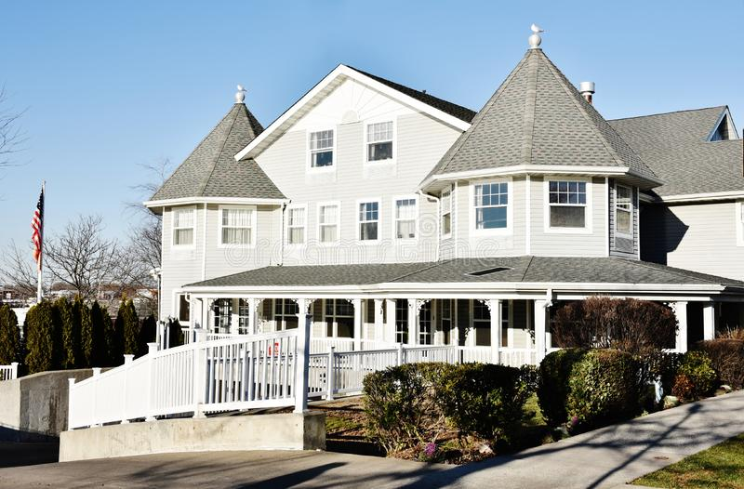
Core abilities are essential nursing roles in nursing competence. A nursing home is a facility for the built-up care of disabled or elderly people. Also, nursing homes are termed as skilled nursing facilities home for the old people, a long-term care facility, rest homes, care homes, convalescent care as well as convalescent homes. However, there are different types of nursing homes depending on the ownership. Therefore, there are private nursing homes and public nursing homes, but the main goal of both is to provide assisted living, nursing care as well as emergency medical care to the disabled or the aged. The above photo is a nursing home building design in New York in the United States of America.
The building is among the nursing home whereby retired people get everything for their health as well as social needs. In this nursing home found in the United States of America, people do not need to be hosted in a hospital because of disability or age because they are given enough care from the home which is done in many ways. First, there are doctors who live in the nurse home to ensure that they respond immediately to any emergency that might take place at any time of the day. The other way is through scheduling of clinical checkups within the nursing homes, whereby special doctors from the public and private hospitals come over to check those in the nursing homes. Moreover, care is provided by ensuring that these individuals are provided with the basic things, such as food, clothing, and a conducive living environment whereby they can simply feel free, relaxed, and contended.
In the United States of America, almost 1 in every 10 residents aged between 75-84 years live in nursing homes for a period of about five years or even more while about 3 in 10 residents of residents live in nursing homes for a period not exceeding 100 years. Nevertheless, nursing homes are having an initiative of providing short-range rehabilitative stays following things such as illness, surgery, or injury. Also, other services offered in the nursing homes are physical therapy, speech-language therapy as well as occupational therapy. Nonetheless, they offer housekeeping, planned activities, and memory care services known as dementia care.
For the sake of ensuring safety and security to the people in nursing homes, all staff has to be licensed and uphold a certificate in their state of work. Every nursing home should meet some specified requirements. For instance, there should be at least a registered nurse for 8 hours who should be monitoring everyone in the nursing home and a licensed practical nurse who is available for 24 hours. Also, there should be social workers, physical therapists, and certified nursing assistants to ensure that everything runs smoothly and as anticipated.
Depending on the nursing home size, a nursing home needs an executive director or a nursing home administrator who should oversee the staff, financial matters of the nursing home, and supplying medical supplies. Human resource personnel is another requirement in a nursing home. They are at the head of facets of hiring new employees, coordinating payroll, organizing orientation programs, disciplinary actions interviewing, and implementing compliance with the state and federal laws.
To me, the above photo has a lot of meanings. First, it gives me an implication of care and unity. This is because people take it as an initiative to protect people who are not even related to them regardless of their condition and race. This is why people prefer to go to live in a nursing home than going to a hospital, a place where there is a guarantee of enough security, protection, and satisfaction of their needs. Another meaning of the photo is kindness. Citizens in the United States of America portray kindness towards everyone, more so the aged and disabled. This is evidenced in the case where people sacrifice resources so as to establish nursing homes, something which is costly and needs to meet several requirements.
Charity begins at home! In relation to the photo on a nursing home building design in New York in the United States of America, I have emotions towards the event. The event that takes place in the photo has a lot of significance to everyone. As we all know, at an age of about 75 years and above we need a lot of care in terms of physical appearance and health. The act of people and government taking the responsibility of providing care to this aged and disabled have a strong emotion of patriotism something which is not common in many countries. Also, I am emotional towards how these people have intensified unity and kindness to ensure that there is no discrimination of anyone as a society of the United States of America as well as eradication of racial differences.
Nevertheless, as a citizen of the United States of America, I have developed a trust emotion toward the government by working in all dimensions to provide well-being for the less privileged in the society in terms of age and physical appearance. Another emotion I get from the photo is joy. This results from the happiness of the aged and disabled because they feel that there are people who care for them and that is why they even prefer to go to a nursing home rather than going to the private or public hospitals which are assured of getting care at relatively low expenses. In summation, whenever I hear about nursing homes on television, I always get an amazing emotion on how awareness concerning home nursing is being created and enhanced.

Reference
296 USA Nursing Photos - Free & Royalty-Free Stock Photos from Dreamstime

